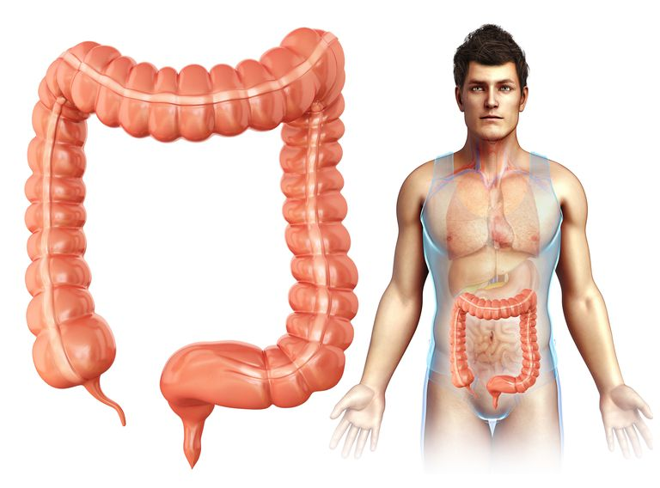COLONOSCOPY

You have a reservation for a colonoscopy on

(time)

The colonoscopy is preformed at the Surgical Unit of the Westfjords Healthcare Institution. You give your name and purpose of visit at the reception and then walk to the right and to the waiting area.

**Take notice**

• You use PICOPREP to prepare your bowel for the colonoscopy. Follow these directions, **not** the ones you find in the PICOPREP package.

• You can buy PICOPREP at a pharmacy without a prescription.

• Videos about colonoscopies can be found on YouTube (in icelandic under: *ristilspeglun ekkert mál).*

• Medicines given to you before the colonoscopy prevent you from driving and handling machinery for at least 4-6 hours afterwards.

**For one week before the colonoscopy**

• Do not eat whole grains, fiber rich food or seeds (coarse bread, musli, og fiber rich vegetables).

• Take a break from iron tablets and lýsi (cod liver oil).

• In some instances you have to take a break from anticoagulant tablets during this week (Kóvar, Plavix, Grepid, Xarelto, Eliquis, Pradaxa), but onlyafter **consulting with your doctor**!

• You can take all other regular medications up to the time of the colonoscopy .

**Two days before the colonoscopy**

• You start to drink/eat only **clear** fluids, i.e. fluids with no vegetable rests, fruit pulp, or fibers.

• You can drink fluids containing sugars and salts.

• No milk or milk products are allowed.

• Drink at least 2 liters during the day - not just water.

• You can drink/eat:

• Filtered broth from soup boullion, oats or rice.

• Filtered, clear vegetable-, fruit- or juice soups.

• Filtered fruit juices.

• Popsicles without milk, cream and chocolate.

• Sodas, clear energy sodas, tea and coffee, you can have sugar in it but without milk.

**One day before the colonoscopy**

• Keep drinking clear fluids.

• At 17:00 , wedneday 15, december you mix one sachet of PICOPREP in a large glass of water, stirring for 2-3 minutes, until the solution stops fizzing and then drink it within 15 min. Take care, that the solution may get warm after mixing, so wait a little, while it cools down.

• After the PICOPREP, you drink at least 2 liters of clear fluids during the next 2 hours. To remember this, it is wise to place the 2 liters of fluids on a table, ready for consumption.

• At least 1 - 6 hours can pass before the PICOPREP has its effect.

• After the PICOPREP consumption, it is necessary that you stay on your feet and move about, to maximize the clearance of all the fluids you have ingested. Stay close to a toilet though.

• You can use a topical ointment (AD ointment, Vaseline) to protect the anal aerea from irritation.

**Second sachet of PICOPREP**

• At 22:00 , wednesday ,december (or ______ hours before the colonoscopy) you mix the second sachet of PICOPREP in a glass of water in the same manner as before.

• After the PICOPREP, you drink at least 2 liters of clear fluids during the next 2 hours.

• You can keep on drinking clear fluids until 2 hours before colonoscopy. After that you fast.

• Important: If there is to be a gastroscopy as well, then you need to fast for 3 hours.

**The procedure in a nutshell**

• See: YouTube - Colonoscopy.

• Before the procedure, you are given an analgesic and a tranquillizer intravenously.

• You lie on your left side, and a long, flexible, hoselike scope is passed up and along the colon.

• Tissue samples (biopsies) can be taken and polyps removed painlessly.

• The procedure takes about 15 to 20 minutes.

**After the colonoscopy**

• If you are already admitted to the hospital, you are moved to the patient ward in your bed.

• Otherwise you stay in the recovery room at the Surgical Unit for 1-2 hours, before you can go home.

• Have somone pick you up at the hospital, as you will be in no condition to drive home yourself.

**The results**

• The doctor will tell you about visible results as soon as the effects of the medication subside.

• The doctor receives the results from the tissue samples in 7-10 days time.

**Further information**

You can get further information from the surgical nurses in tel: 450 4500.

Best regards

from the staff of Westfjords Healthcare Institution, Surgical Unit

Endurskoðað nóv. 2018/HH